

Defining the Strategic Plan

Workbook

November 1, 2023

**Leslie Robin**

Senior Strategist

[lrobin@cnmsocal.org](mailto:lrobin@cnmsocal.org)

**Agenda Topics:**

* Defining Planning and Strategic Planning
* Setting the Context - Breaking Down the Beginning of the Process
* Setting the Direction
* Environmental Scan
* Creating the Plan
* Logic Model
* Wrap- up

**Defining Planning and Strategic Planning**



**Why Plan?**

What is Strategy?

* Strategy is a general plan to achieve one or more goals under conditions of uncertainty.

What is Organizational Strategy?

* Specifies how an organization will allocate resources (fund, labor, inventory) to support goals, infrastructure, marketing, etc.

What is Strategic Decision?

* Strategic decisions are decisions that incorporate many factors such as:
  + The environment in which the organization operates
  + Organizational resources
  + Staff
  + The relationship between staff and resources

**What makes the plan strategic?**

Strategic Plans are living documents with the flexibility to plan for uncertainty considering the 3 primary decisions an organization makes.

**What is Strategic Planning?**

Strategic Planning is a **PROCESS**

* step back
* take stock
* create a future vision
* identify goals
* action plan

**Development of the Plan**

**Review**

**(Vision, Mission, Values)**

**Environmental Scan**

**(external & internal)**

**Analyze & Prioritize**

**Self-Assessment**

**Preparation**

**Types of Plans**

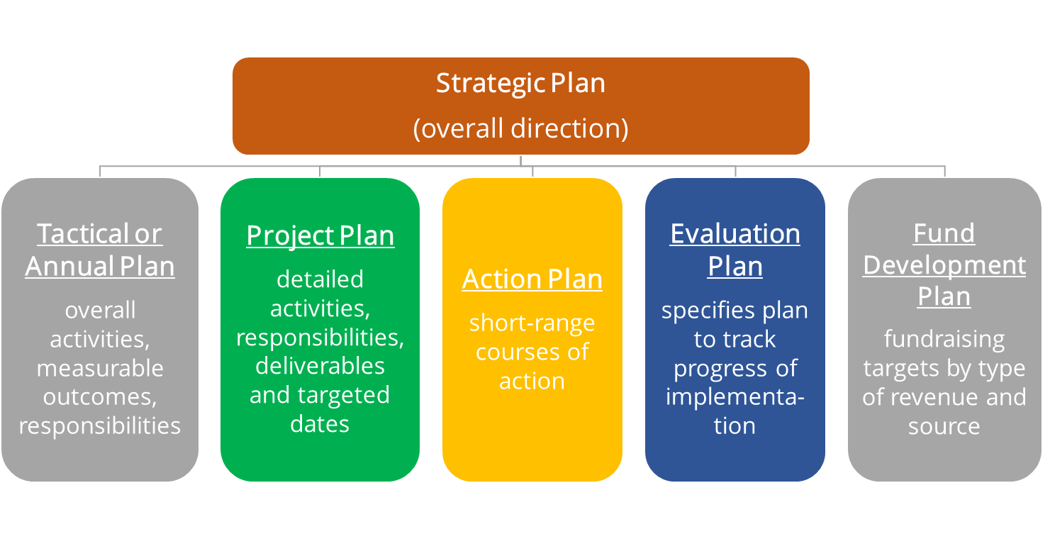

**What is the path?**

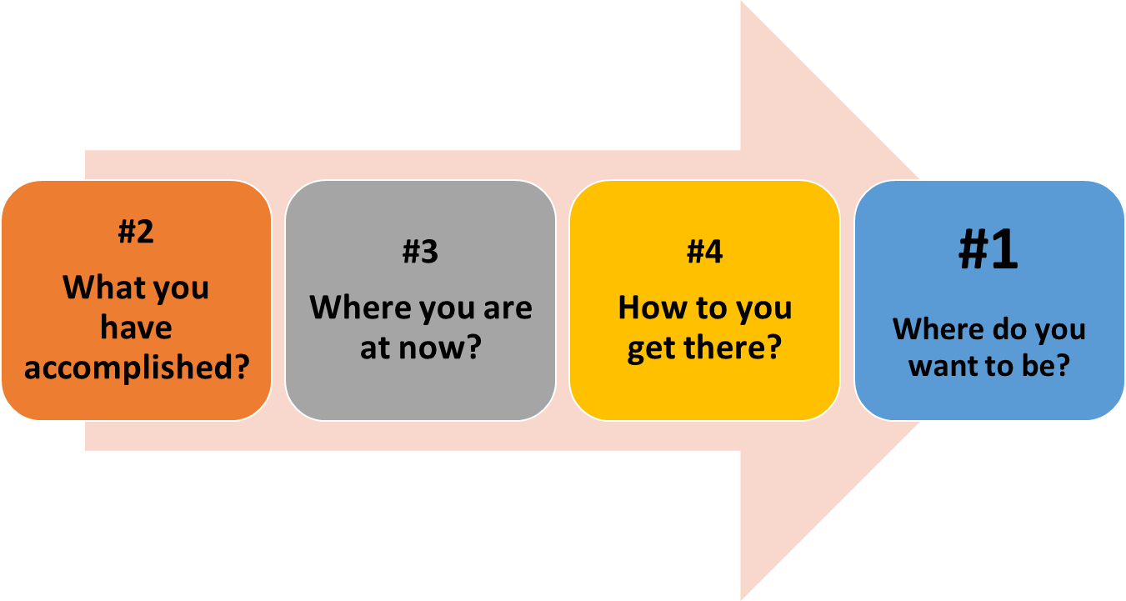

**Setting the Context – Breaking Down the Beginning of the Process**

**Key Questions to Determine Readiness**

* Why Now?  *(Why are you engaging in Strategic Planning now?)*
* What does success look like?
* Planning Period?   *(1-, 2-, 5- years)*
* Resources?   *(Costs, staff time, tech, consultant, research/data)*
* What information is needed to guide your planning?

***Where to begin:* Planning a Strategic Planning Process**

|  |
| --- |
| ***Who:***  **Organization: __________________________________________________**  ***When*:**  **Plan Period: 🗆 1 yr 🗆 3 yrs 🗆 5 yrs 🗆 other ______________________**  **Planning Process Start Date: _________ Process Completion Date: ____________** |
| ***Desired Outcomes***   1. **Besides the plan, what other desired outcomes would you like from the process?** |
| ***Resources Needs***   1. **What planning resources are needed and what are projected costs?**   (staff, travel costs, consultant, site rental fee, research/data) |
| ***Information Needs***   1. **What information is needed to guide our planning?**   (highlight the most important information needed to guide your future planning) |
| ***Planning History***   1. **What previous plans exist (strategic, program, fundraising, marketing, visioning), from when (dates), and how might they be used in this process?** |

***Team:* Planning Participants**

|  |  |  |
| --- | --- | --- |
| ***Players:***  **Who Should be Involved in the Planning Process?**  (List by individual name or function) | ***Position:***  **Participant’s**  **Organizational Title** (Staff, Board, Volunteer, Consultant) | ***Role*:**  **Strategic Planning Process Role** (How can we involve them and what would be their role?) |
|  |  |  |
|  |  |  |
|  |  |  |
|  |  |  |
|  |  |  |
|  |  |  |
|  |  |  |
|  |  |  |
|  |  |  |
|  |  |  |
|  |  |  |
|  |  |  |
|  |  |  |
|  |  |  |
|  |  |  |
|  |  |  |
|  |  |  |

***Groups:* Planning Team and Workgroups**

|  |  |  |
| --- | --- | --- |
| **Committees & Workgroups for the Planning Process** | **Purpose & Products** (research, develop budget, conduct interviews, etc.) | **Staff or Board Lead** |
|  |  |  |
|  |  |  |
|  |  |  |
|  |  |  |
|  |  |  |

***When:* Planning Timeline**

|  |  |  |  |  |  |  |  |
| --- | --- | --- | --- | --- | --- | --- | --- |
| ***Start:* Plan Process Start and Completion Date: ________________________** | | | | | | | |
| ***What:***  **Activity or Benchmark** | ***Who:***  **Person(s) Responsible** | ***When:* Time Periods** | | | | | |
|  |  |  |  |  |  |
|  |  |  |  |  |  |  |  |
|  |  |  |  |  |  |  |  |
|  |  |  |  |  |  |  |  |
|  |  |  |  |  |  |  |  |
|  |  |  |  |  |  |  |  |
|  |  |  |  |  |  |  |  |

**Meaningful Engagement: Who can be included in the process**

**Setting the Direction**

|  |  |
| --- | --- |
| Mission | “The impact your organization is going to create….” |
| Values | “What are your beliefs?” |
| Vision | “Change in the community” |
| Goals | “Short to long-term quantification of key goals” |
| Tactics/Initiatives | “An action to be taken to implement goals…” |
| Measures/Targets | “Measure of performance…” |

**Tweet Your Mission**



What is the impact your organization makes in 140 characters?

**Values and Beliefs**

What core beliefs guide my organization? What makes my organization unique? We believe…



**Values***What do you believe?*

**Environmental Scan**

|  |  |
| --- | --- |
| **Types of Information** | **Methods/Source** |
|  |  |
|  |  |
|  |  |
|  |  |
|  |  |
|  |  |

**Assessing the Environment**

**SWOT Analysis**

|  |  |
| --- | --- |
| **Strengths**   1. What are your strengths? 2. What do you do better than others? 3. What unique capacities and resources do you possess? 4. What do others perceive as your strengths? | **Challenges (Weaknesses)**   1. What are your challenges? 2. What do your competitors do better than you? 3. What can you improve given the current situation? 4. “What keeps you up at night?” |
| **Opportunities**   1. What trends or conditions may positively impact you? 2. What opportunities are available to you? 3. What environmental, economic, demographics changes have created new prospects? | **Obstacles (Threats)**   1. What are the obstacles that prevent you from taking advantage of the opportunities? 2. What prevents you from building on your strengths? 3. With money as an obstacle, what prevents you from securing more money? 4. What gets in the way, real or perceived, of implementing new plans and recommendations? |

**SWOT Worksheet**

|  |  |
| --- | --- |
| **Strengths** | **Challenges (Weaknesses)** |
| **Opportunities** | **Obstacles (Threats)** |

**Creating the Plan**

**Team Conversations & Putting It on Paper**

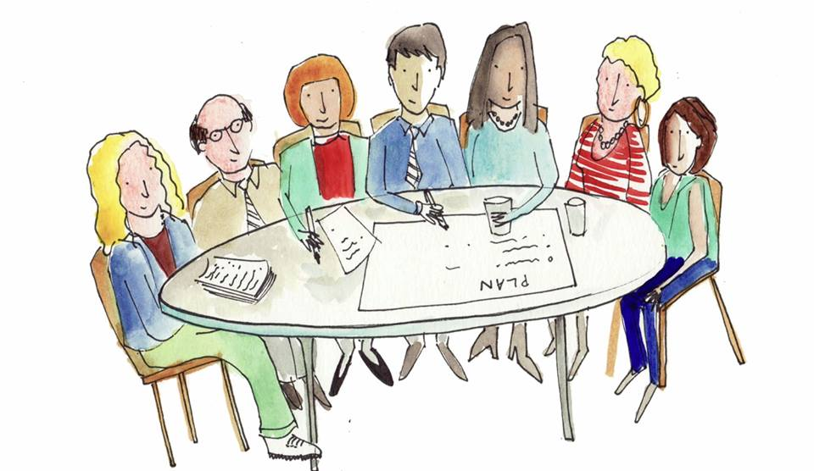

**SMARTIE Objectives**

All in one sentence

**Logic Model**

*A systematic and visual way to present and understand the relationship*

*between your resources, activities, and results*

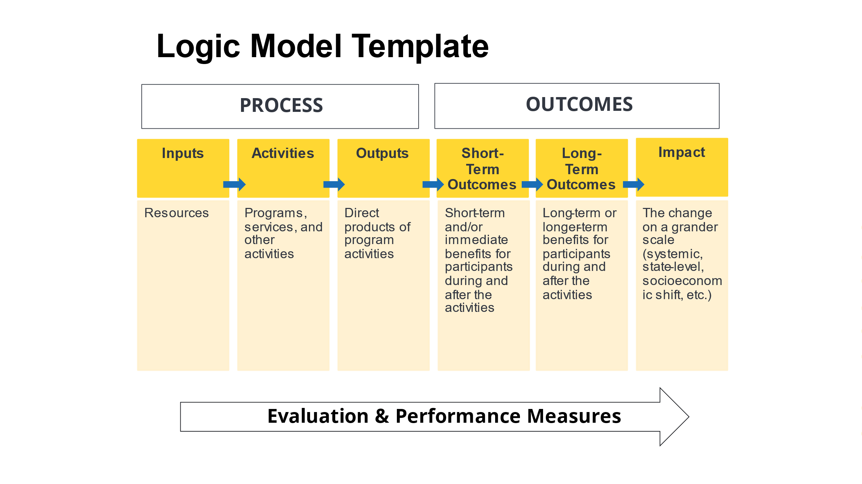

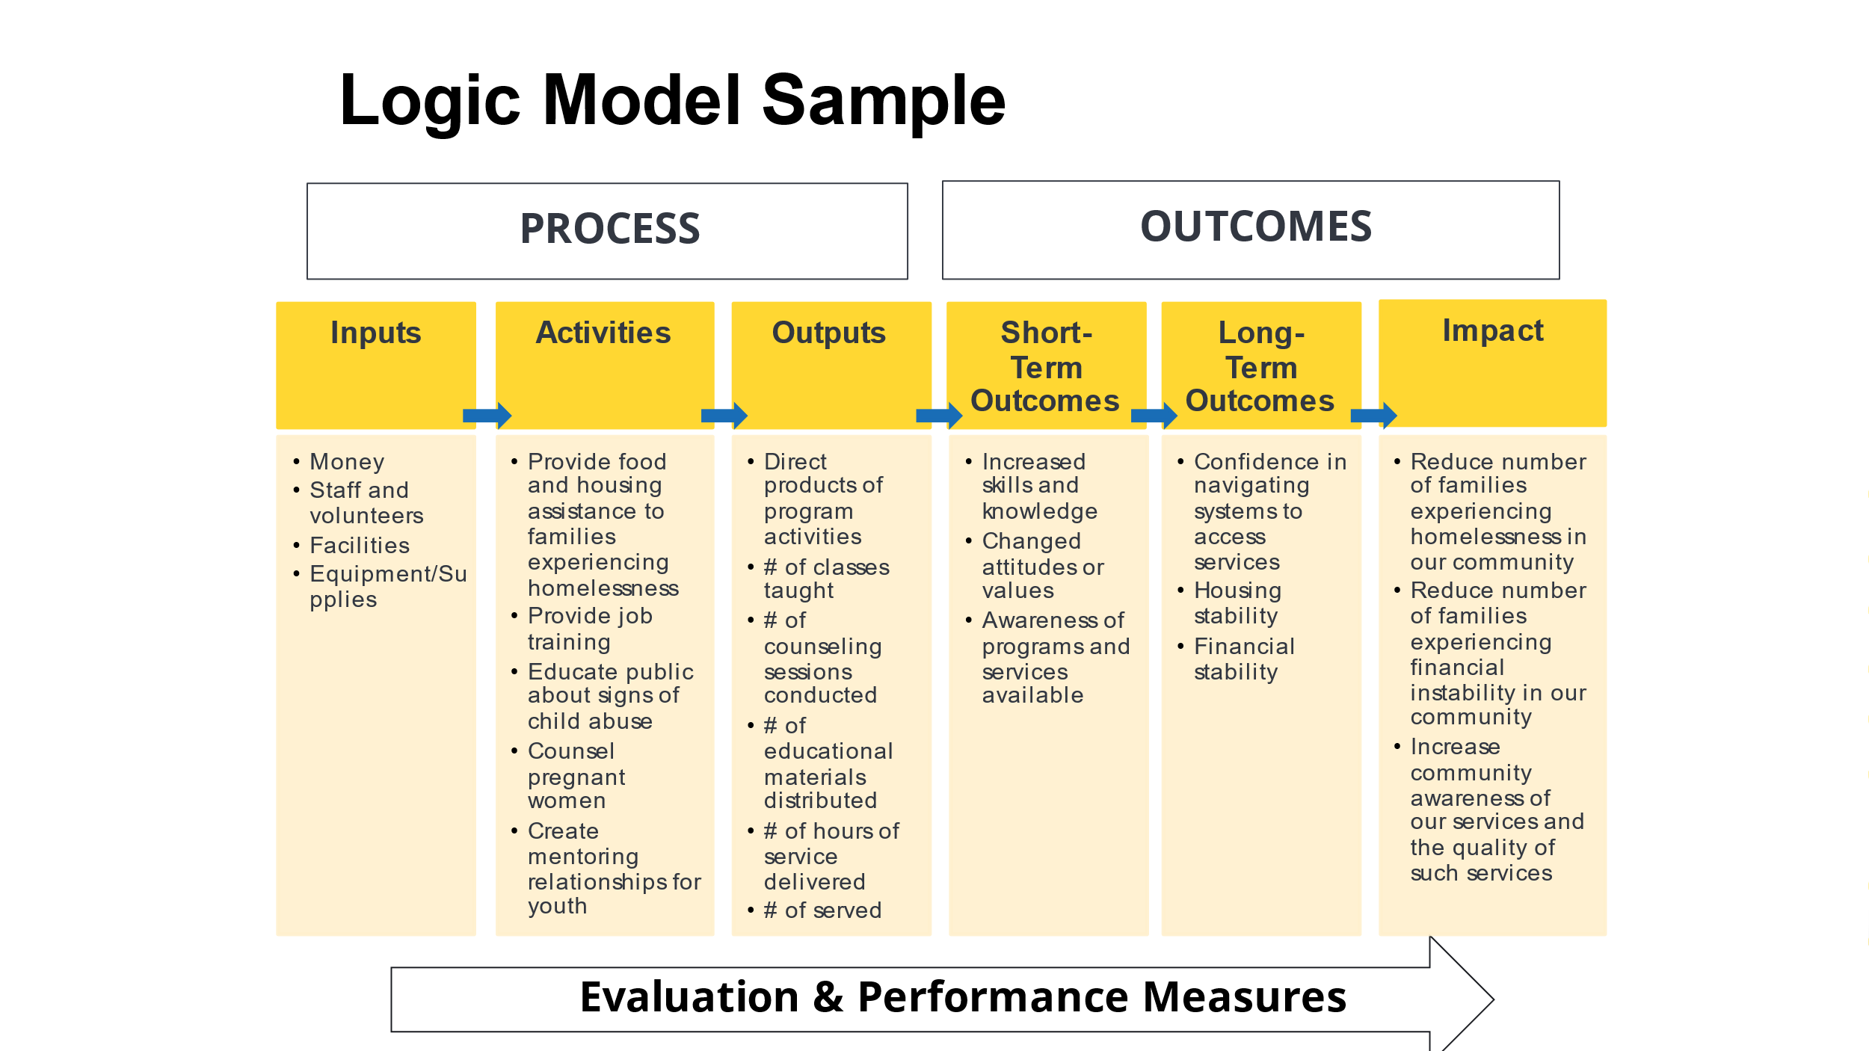

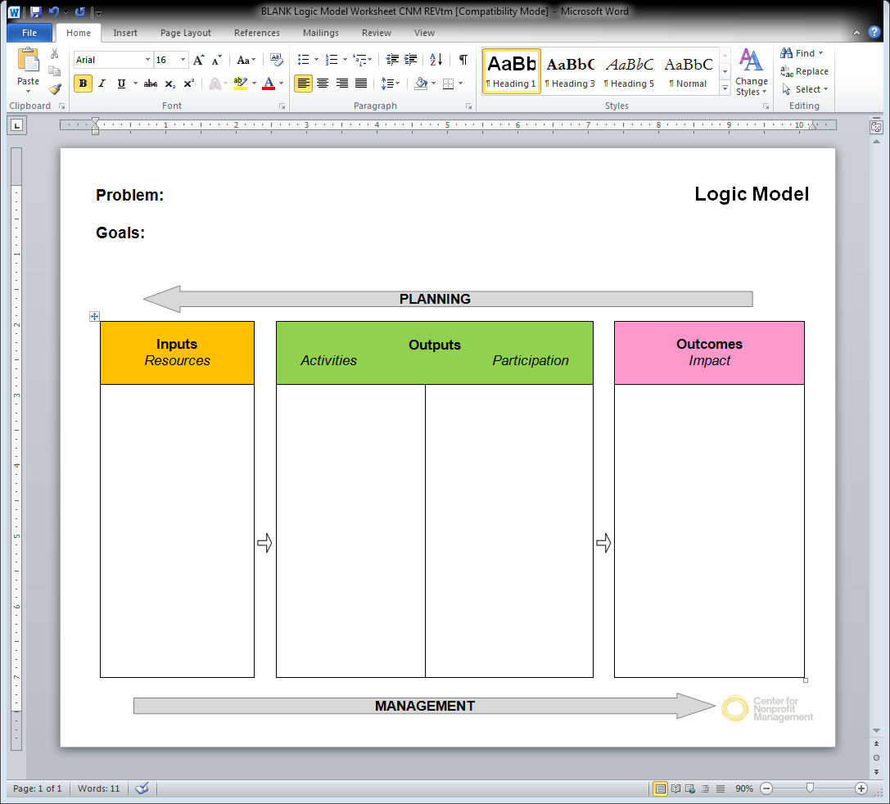

**Logic Model Case Study 1: Diabetes Medical Follow Up**

Problem:

The Harriman Jones Medical Group is seeing a disproportionately high number of patients with diabetes in the Emergency Room. Many were coming in repeatedly as they did not know how to properly care for their condition. Patients expressed interest in participating in educational programs and support groups, as well as receiving RN follow-up by phone to work on their prescribed diet, exercise, and medication.

Goal:

The goal is to reduce ER visits as well as improve health outcomes.



19

**Logic Model Case Study 2: College Access and Readiness**

Problem:

Many students at Brooklyn Center Jr. High School doubt their ability to go to college. Reasons include: mediocre grades, friends and family do not discuss college, funding college, college entrance exams, navigating the college application process. The school is piloting a program where 60 seventh-graders will receive college readiness support for one class period each day. This program also offers them afterschool support. The school is targeting youth with potential but need support in seeing that college is a viable option.

Goal:

Students are college ready and college bound



**Wrap-up and Next Steps**

What is one thing that you are taking away from today’s session?

